

Department of” Bachelor of Computer Application”

Ness Wadia College of Commerce, Pune.

Academic Year 2021-22.

semester – v

**A PROJECT REPORT ON**

**“Fake News Detection website USing machine Learning”**

Submitted To

Savitribai Phule Pune University

Submitted By

Tushar Soni (33)

Mihir mandviya (42)

Under the Guidance of

Prof. Seema Purandhare

PRof. Ashwini waghmare

ACKNOWLeDGEMENT

The satisfaction that accompanies that the successful completion of any task would be incomplete without the mention of people whose ceaseless cooperation made it possible, whose constant guidance and encouragement crown all efforts with success.

We are grateful to our project guide **PROF. SEEMA PURANDHARE AND PROF. ASHWINI WAGHMARE** for the guidance, inspiration and constructive suggestions that helped us in the preparation of this project.

We also acknowledge with sense of reverence my gratitude towards the **PROF.SEEMA PURANDHARE** (HOD) of Dept. of BCA for providing us an opportunity to work in project.

Lastly we are also thankful to our parents and colleagues who have helped us in successful completion of the project.

**Yours Sincerely,**

Mast. Tushar Soni.

Mast. Mihir Mandviya.

index

|  |  |  |  |
| --- | --- | --- | --- |
| No. |  | Title | Page No |
| **1.** |  | **Introduction** |  |
|  | 1.1  1.2  1.3 | Problem Definition  Need for the New System  Project Scope | 4  5  6 |
| **2** |  | **Analysis** |  |
|  | 2.1 | Feasibility Study   * Technical Feasibility * Economical Feasibility * Operational Feasibility | 7 |
|  | 2.2 | Hardware and Software Requirements | 8 |
| **3** |  | **Design** |  |
|  | 3.1 | ER Diagram | 9 |
|  | 3.2 | DFD Diagram | 11 |
|  | 3.3 | Database Design | 13 |
| **4** |  | **Screenshots** | 16 |
| **5** |  | **Limitations** | 33 |
| **6** |  | **Future Enhancement** | 34 |
| **7** |  | **References and Bibliography** | 35 |

**introduction**

problem DEFINATION:

*Fake news is written and published usually with the intent to mislead to damage an agency, entity, or person, and/or gain financially or politically, often using sensationalist, dishonest, or outright fabricated headlines to increase readership.*

*The news often reverberates as misinformation in social media but occasionally finds its way to the mainstream media as well. On the other hand, it may also involve narration of a true fact however being deliberately exaggerated. This may also include titling the web pages with misleading titles or taglines in order to seize the attention of readers.*

*Such misinformation may lead to committing offences, social unrest, financial frauds upon such misrepresentation, political gain, to increase the number of readers, gain revenue associated with clickbait, etc. The extensive spread of fake news has the potential for extremely negative impacts on individuals and society.*

*.*

Need of system:

*As an increasing amount of our lives is spent interacting online through social media platforms, more and more people tend to hunt out and consume news from social media instead of traditional news organizations.[1] The explanations for this alteration in consumption behaviours are inherent within the nature of those social media platforms: (i) it's often more timely and less expensive to consume news on social media compared with traditional journalism, like newspapers or television; and (ii) it's easier to further share, discuss, and discuss the news with friends or other readers on social media.*

*Despite the benefits provided by social media, the standard of stories on social media is less than traditional news organizations. However, because it's inexpensive to supply news online and far faster and easier to propagate through social media, large volumes of faux news, i.e., those news articles with intentionally false information, are produced online for a spread of purposes, like financial and political gain.*

*Given the prevalence of this new phenomenon, “Fake news" was even named the word of the year by the Macquarie Dictionary in 2016. Hence there is a need for a system that will check if given news is real or not. So, we have made a fake news detection model which detects the reality of the news.*

project scope:

*This project will contribute to the start of a new revolution against one of the most prevalent hazards i.e. spread of Fake News. It will serve as root and branch eradication of the same.*

*This project will help to create the next level of awareness and make the citizens more responsible. This project will help users to analyse between fake and real news which is spreading around the world user can easily filter the news with the help of our website, we try to filter and proved the best and most accurate result with 93.69+% accuracy with a machine learning algorithm.*

*This project will help the people of a nation to take meaningful and informed decisions.*

Feasibility Study:

*The feasibility of the system can be examined under heads viz. Technical feasibility, Economical feasibility & Operational feasibility.*

1. ***Technical Feasibility –****In Technical Feasibility current resources both hardware software along with required technology are analysed/assessed to develop project. This technical feasibility study gives report whether there exists correct required resources and technologies which will be used for project development. Along with this, feasibility study also analyses technical skills and capabilities of technical team, existing technology can be used or not, maintenance and up-gradation is easy or not for chosen technology etc.*

1. ***Operational Feasibility –****In Operational Feasibility degree of providing service to requirements is analysed along with how much easy product will be to operate and maintenance after deployment. Along with this other operational scopes are determining usability of product, determining suggested solution by software development team is acceptable or not etc.*

1. ***Economic Feasibility –****In Economic Feasibility study cost and benefit of the project is analysed. Means under this feasibility study a detail analysis is carried out what will be cost of the project for development which includes all required cost for final development like hardware and software resource required, design and development cost and operational cost and so on. After that it is analysed whether project will be beneficial in terms of finance for organization or not.*

HArdware and software requirements:

*1)* ***Hardware Requirement****:-*

*The minimum requirements of hardware are as follows:*

***Processor****: Intel(R) core(TM) i3-5005U CPU @ 2.00GHz 2.00GHz*

***HDD****: 256 GB or above.*

***RAM****: 4 GB or above.*

*2)* ***Software requirement****:-*

*The minimum requirement of software is as follows:*

***Operating system****: Windows 10*

***Front end****: HTML, CSS, JS, Bootstrap*

***Back End****: PHP, MySQL*

***Database****: phpMyAdmin*

***Machine Learning****: Python, Jupyter Notebook*

***Document****: MS-Word, MS-Excel*

**ANALYSIS**

er diagram:

***Symbol Used In E-R Diagram****:-*

*The E-R model uses few basic concepts in producing an E-R diagram.*

*These concepts are:-*

*1) Entity*

*2) Relationship*

*3) Attribute*

*1)* ***Entity****:*

*An entity is an object or anything, which is distinguishable from objects.*

*2)* ***Relationship****:*

*A relationship is meaningful association, a linking or connection between entities.*

*3)* ***Attribute****:*

*An attribute is any aspect quality or description of either an entity or relationship.*

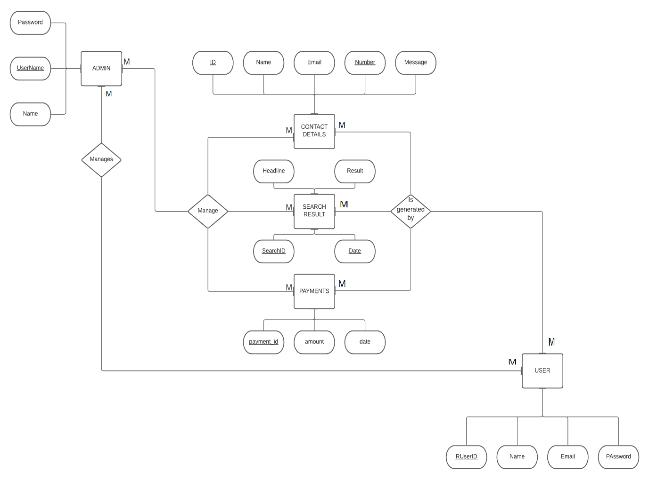

DFD (Data flow diagram)

level 0:

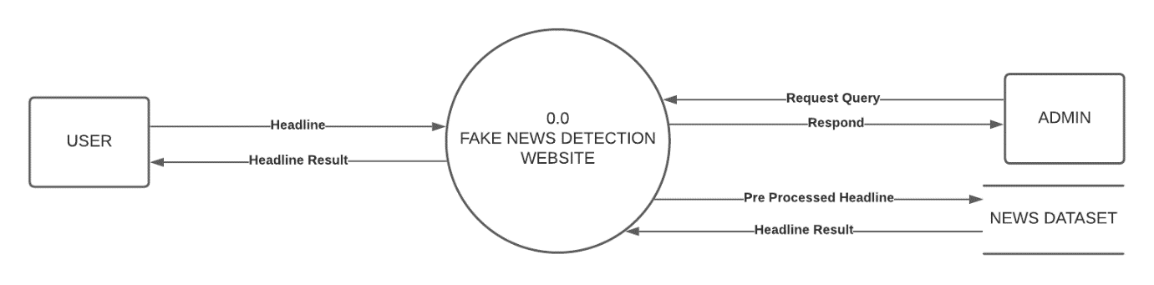

level 1:

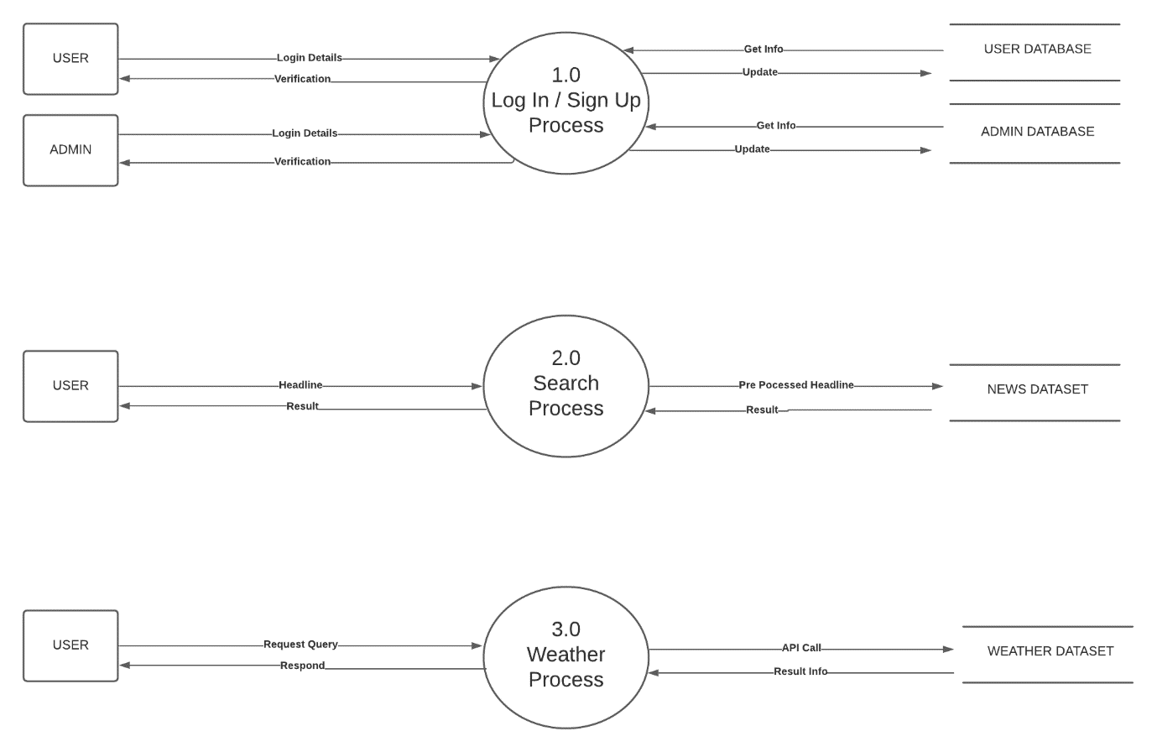

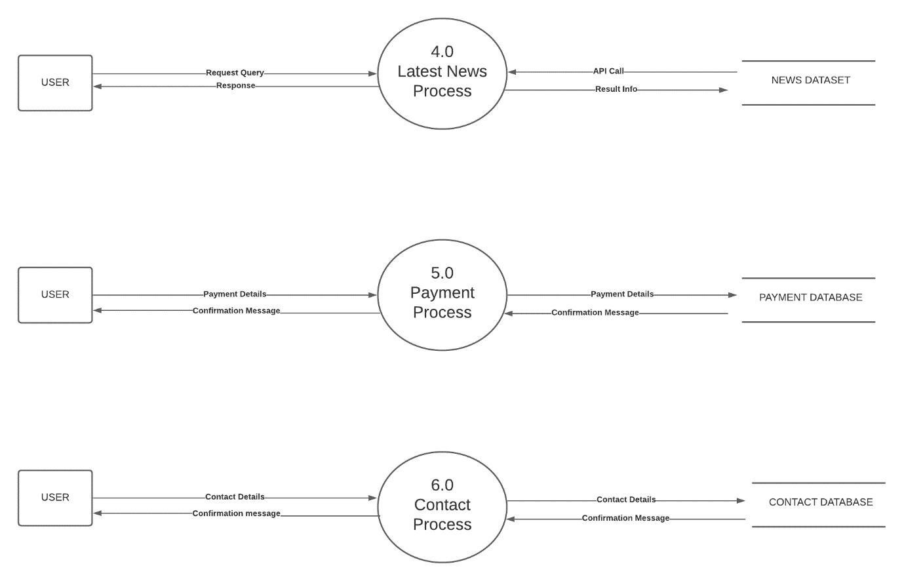

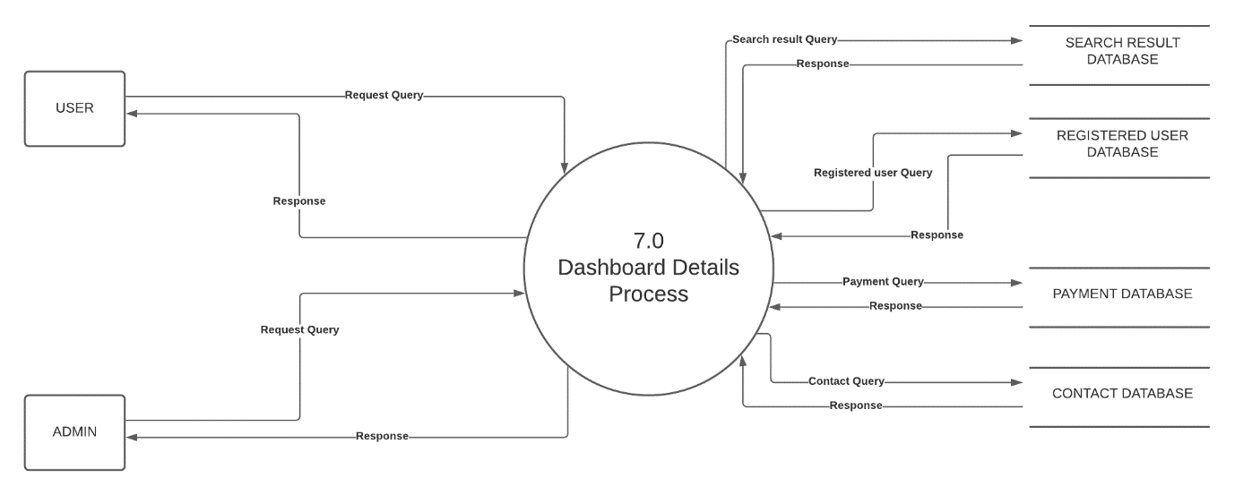

**data base design**

data table:

***1. admin***

|  |  |  |  |  |
| --- | --- | --- | --- | --- |
| ***Sr No.*** | ***Field Name*** | ***Data Type*** | ***Size*** | ***Constraints*** |
| *1* | *UserName* | *varchar* | *20* | *Primary key* |
| *2* | *Name* | *varchar* | *30* | *Not Null* |
| *3* | *Password* | *varchar* | *100* | *Not Null* |

***2.*** ***registered_user***

|  |  |  |  |  |
| --- | --- | --- | --- | --- |
| ***Sr No.*** | ***Field Name*** | ***Data Type*** | ***Size*** | ***Constraints*** |
| *1* | *RUserID* | *int* | *5* | *Primary key* |
| *2* | *Name* | *varchar* | *30* | *Not Null* |
| *3* | *Email* | *varchar* | *30* | *Not Null* |
| *4* | *Password* | *varchar* | *100* | *Not Null* |

***3.*** ***search_result***

|  |  |  |  |  |
| --- | --- | --- | --- | --- |
| ***Sr No.*** | ***Field Name*** | ***Data Type*** | ***Size*** | ***Constraints*** |
| *1* | *SearchID* | *Int* | *5* | *Primary key* |
| *2* | *Headline* | *varchar* | *250* | *Not Null* |
| *3* | *Result* | *varchar* | *5* | *Not Null* |
| *4* | *Date* | *date* |  | *Not Null* |

***4.*** ***ruser_join***

|  |  |  |  |  |
| --- | --- | --- | --- | --- |
| ***Sr No.*** | ***Field Name*** | ***Data Type*** | ***Size*** | ***Constraints*** |
| *1* | *RUserJoinID* | *int* | *5* | *Primary key* |
| *3* | *RUserID* | *int* | *5* | *foreign key* |
| *4* | *SearchID* | *int* | *5* | *foreign key* |

***5.*** ***payment***

|  |  |  |  |  |
| --- | --- | --- | --- | --- |
| ***Sr No.*** | ***Field Name*** | ***Data Type*** | ***Size*** | ***Constraints*** |
| *1* | *payment_id* | *varchar* | *30* | *Primary key* |
| *2* | *amount* | *int* | *3* | *Not Null* |
| *3* | *date* | *date* |  | *Not Null* |

***6. payuser_join***

|  |  |  |  |  |
| --- | --- | --- | --- | --- |
| ***Sr No.*** | ***Field Name*** | ***Data Type*** | ***Size*** | ***Constraints*** |
| *1* | *PayUserJoinID* | *int* | *5* | *Primary key* |
| *2* | *RUserID* | *int* | *5* | *foreign key* |
| *3* | *payment_id* | *varchar* | *30* | *foreign key* |

***7.*** ***contact***

|  |  |  |  |  |
| --- | --- | --- | --- | --- |
| ***Sr No.*** | ***Field Name*** | ***Data Type*** | ***Size*** | ***Constraints*** |
| *1* | *ID* | *int* | *10* | *Primary key* |
| *2* | *Fname* | *varchar* | *15* | *Not Null* |
| *3* | *Lname* | *varchar* | *15* | *Not Null* |
| *4* | *Email* | *varchar* | *30* | *Not Null* |
| *5* | *Number* | *varchar* | *10* | *Not Null* |
| *6* | *Message* | *varchar* | *500* | *Not Null* |

screenshots

**INDEX PAGE**



**HEADLINE SECTION**



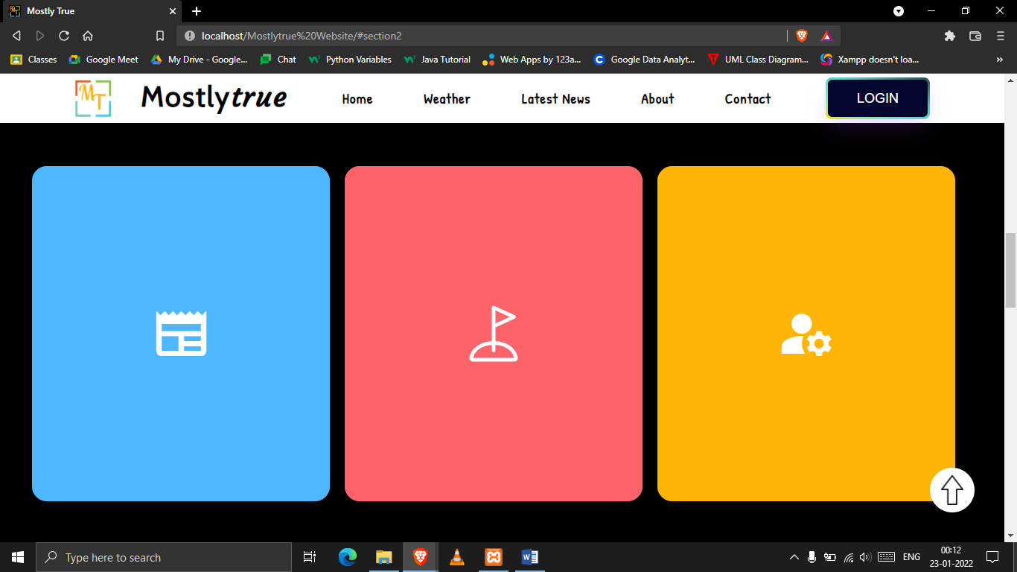

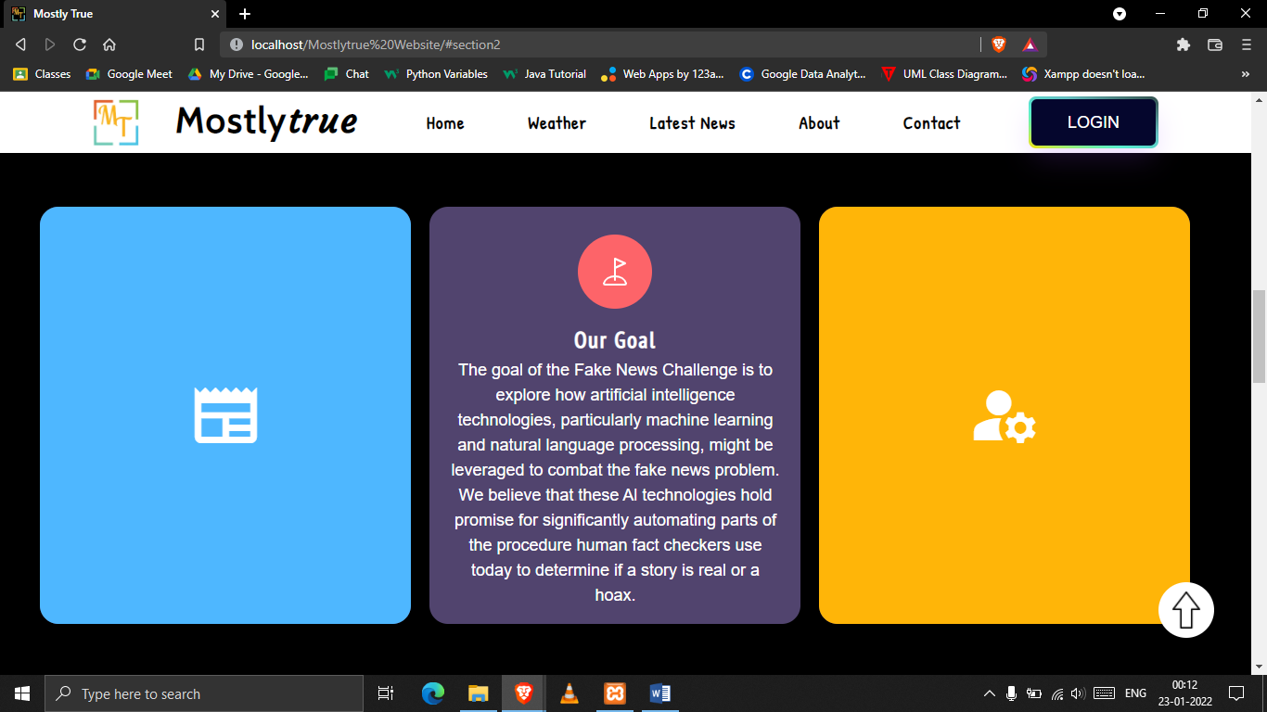

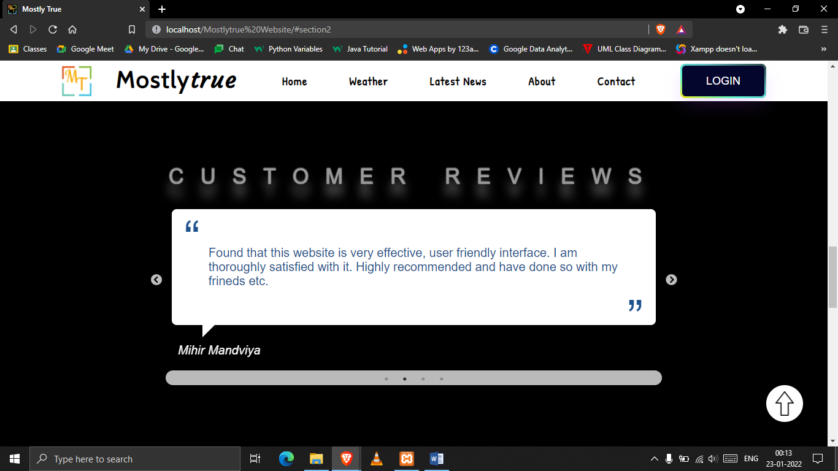

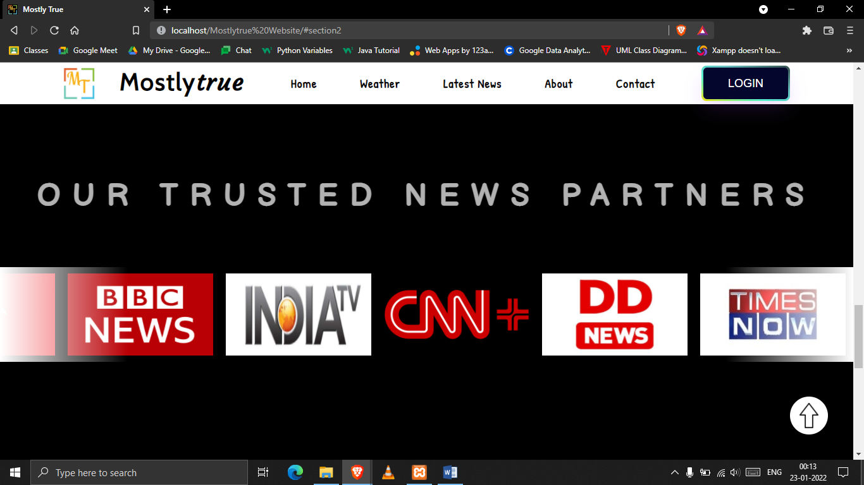

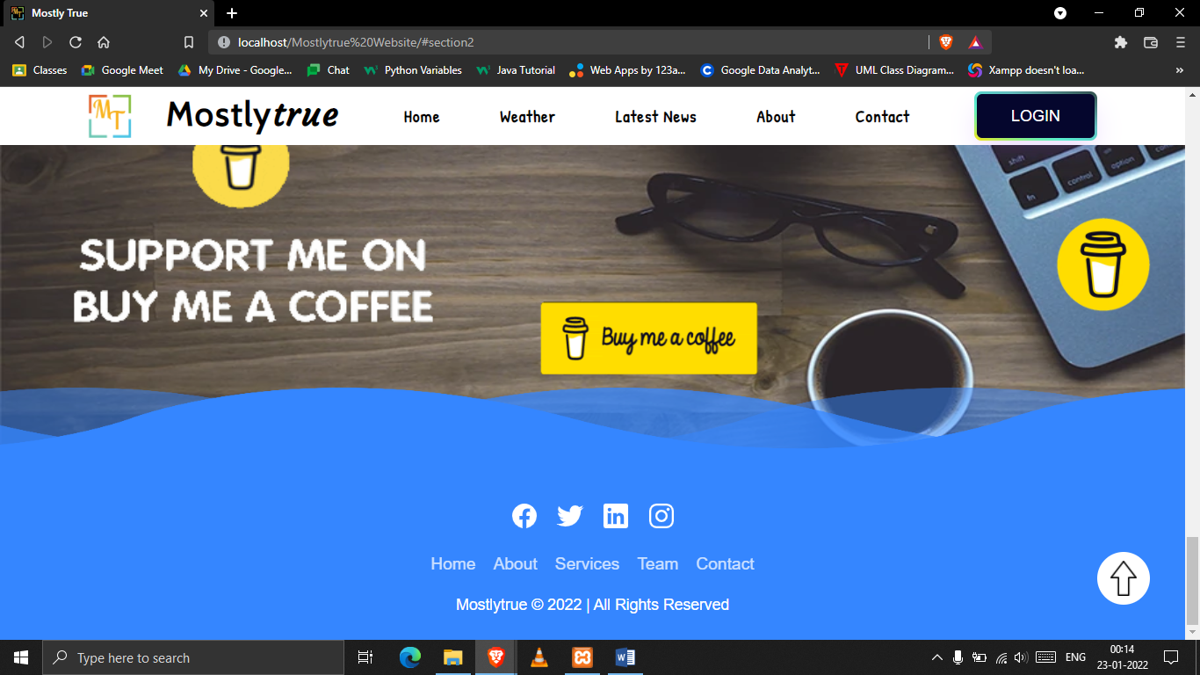

**PAYMENT SECTION**

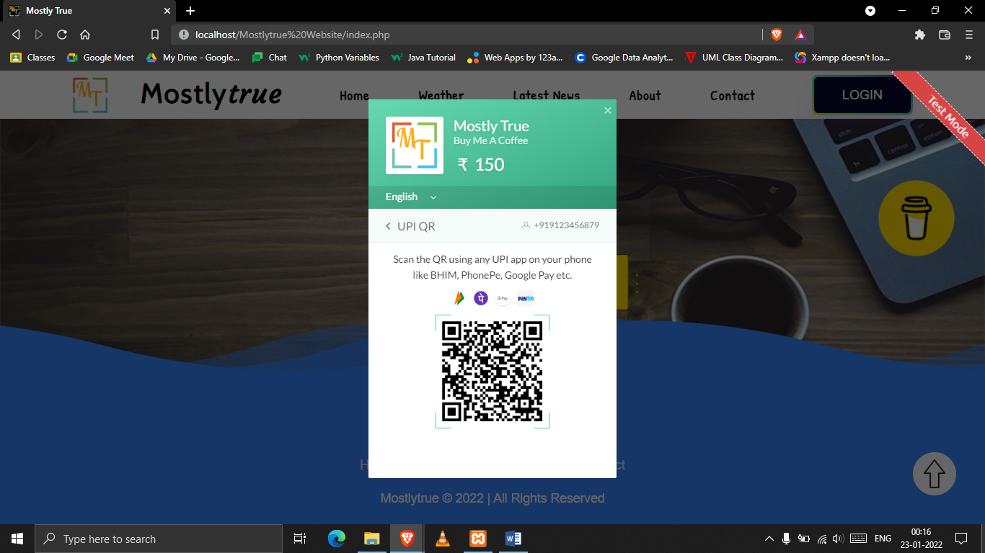

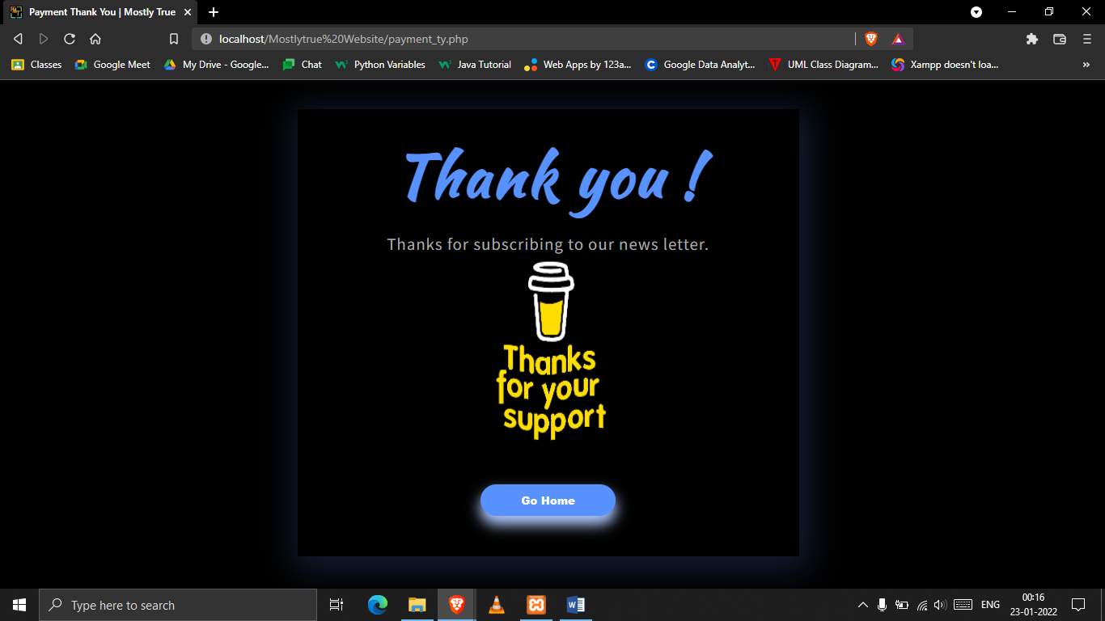

**WEATHER PAGE**

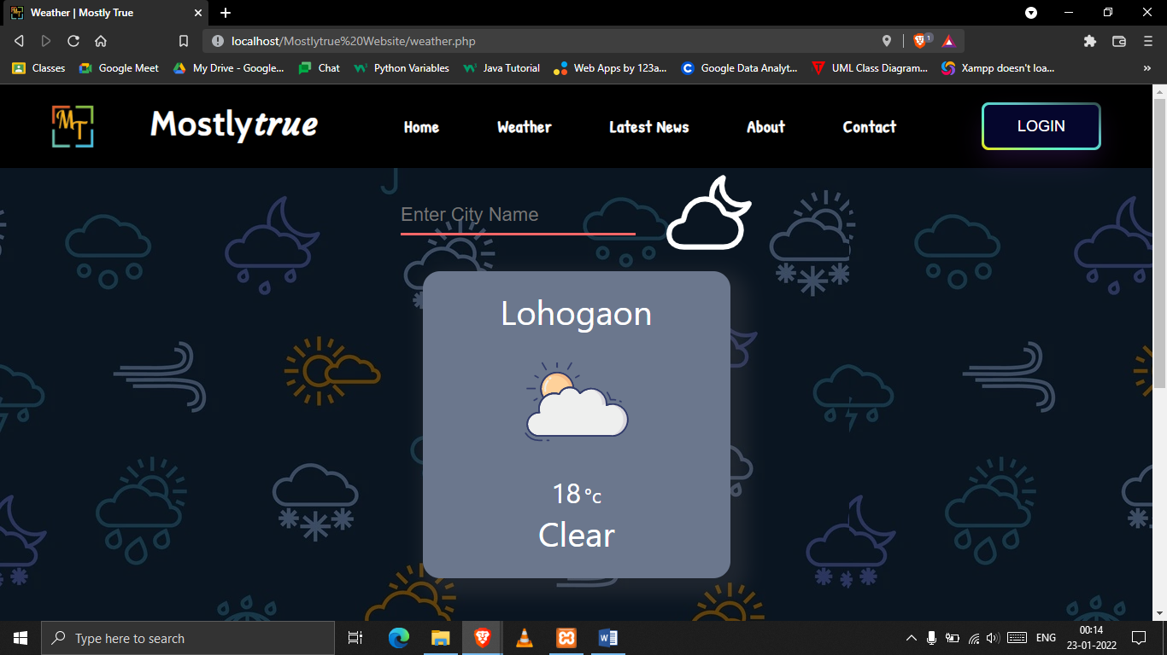

**LATEST NEWS PAGE**

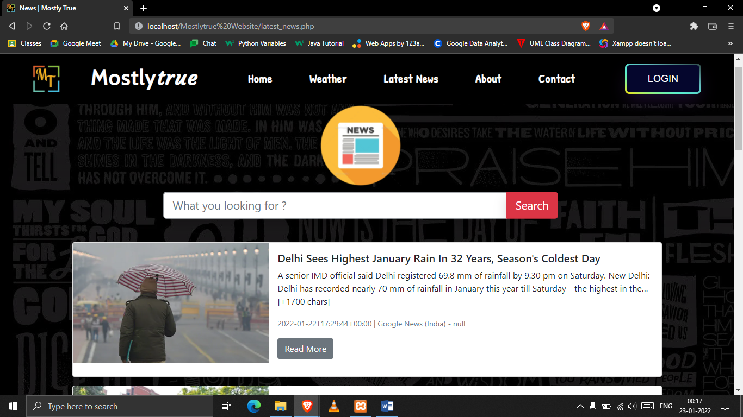

**ABOUT US PAGE**

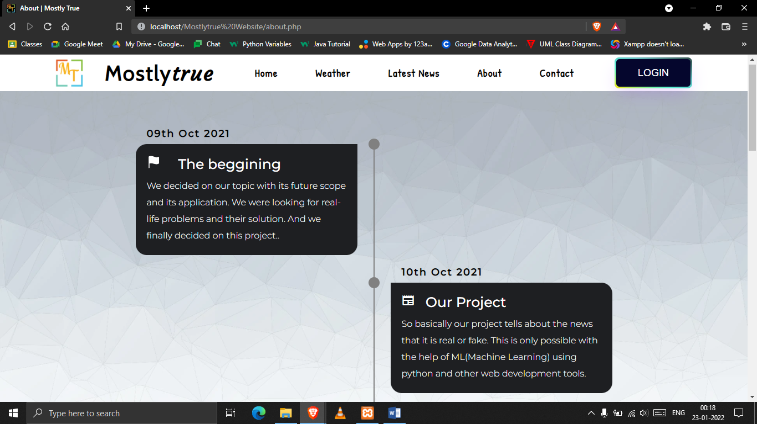

**CONTACT US PAGE**

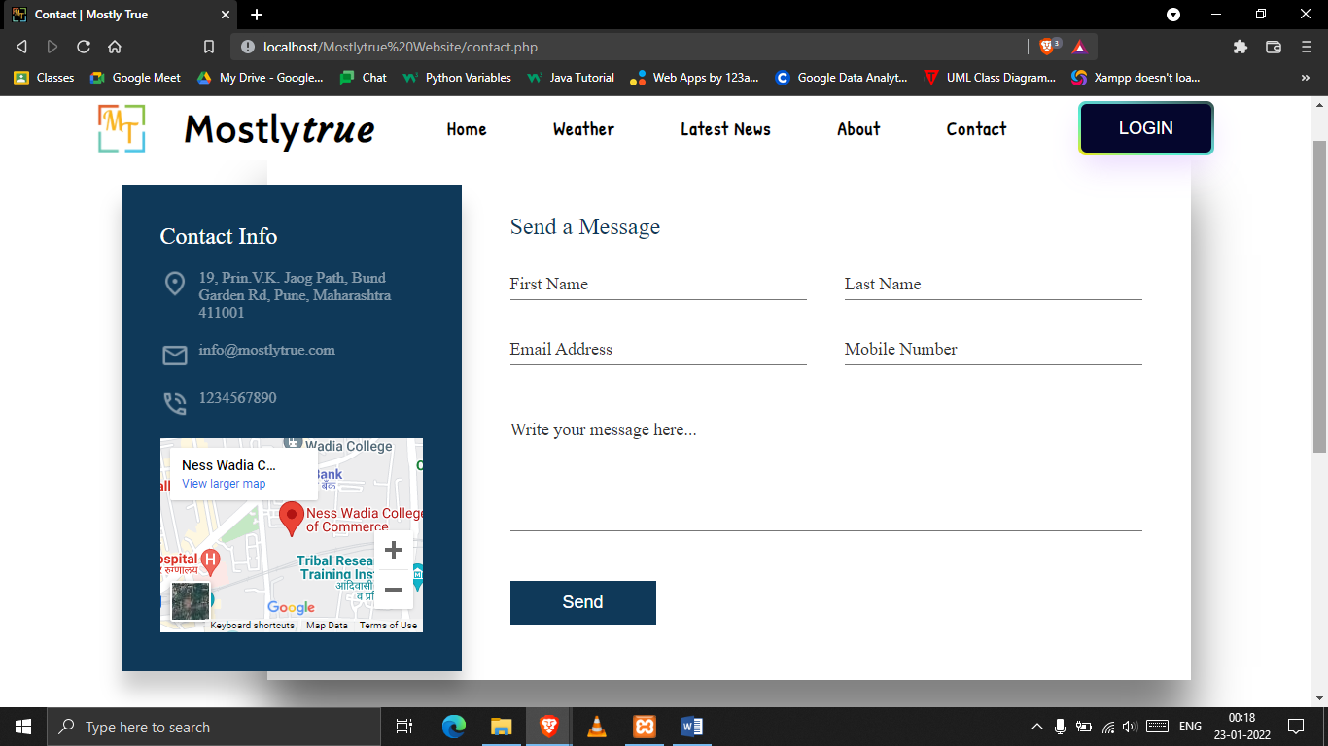

**SERVICES PAGE**

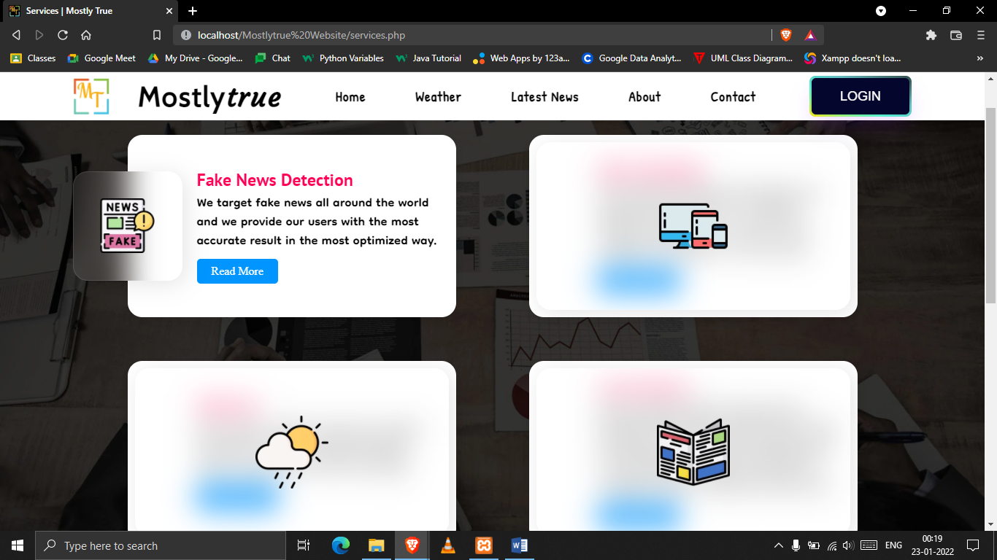

**TEAM’S PAGE**

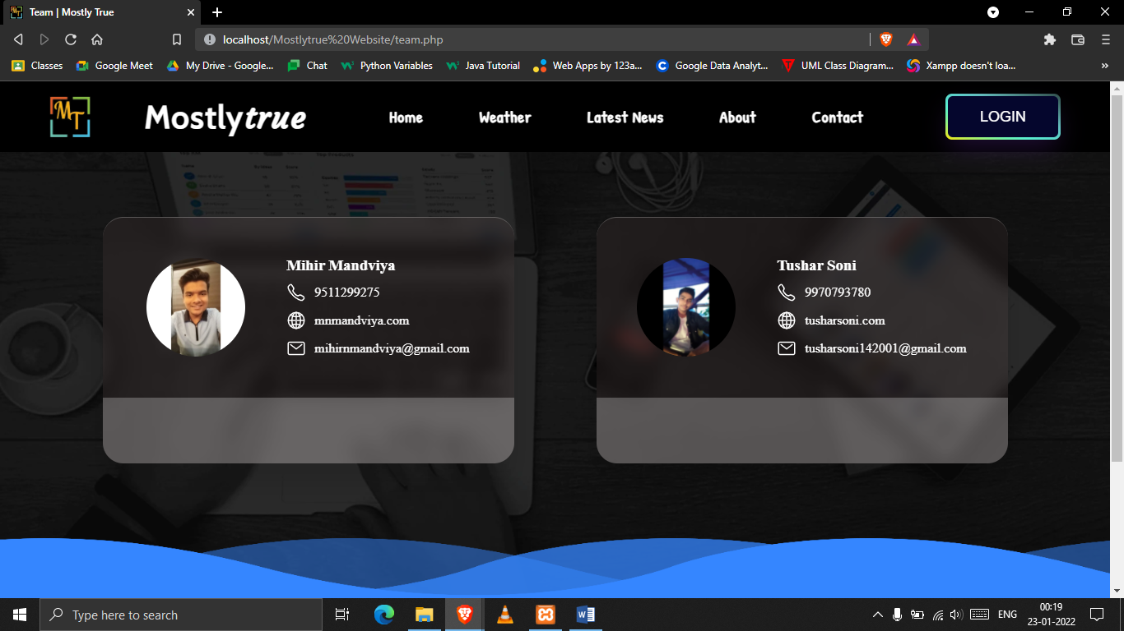

**LOG IN PAGE**

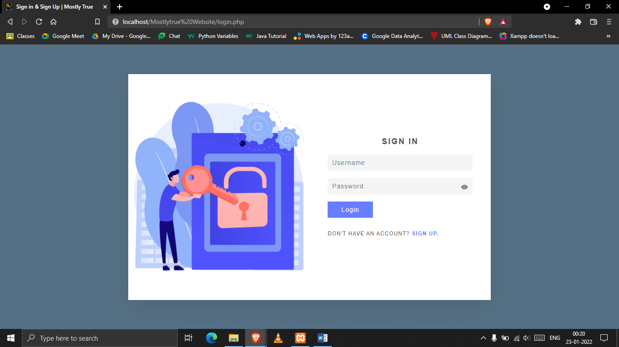

**SIGN UP PAGE**

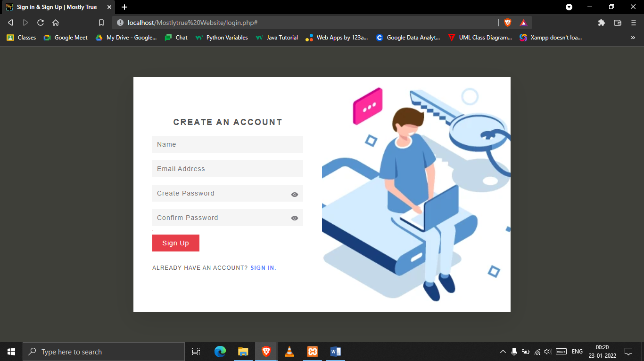

**VALIDATION**

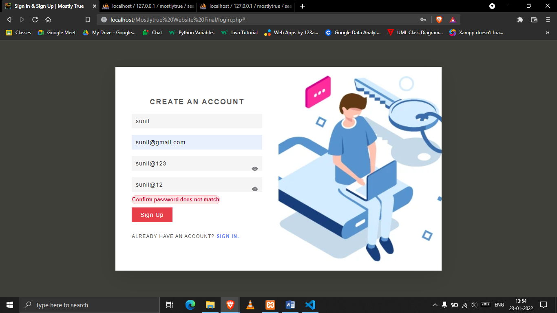

**ADMIN DASHBOARD**

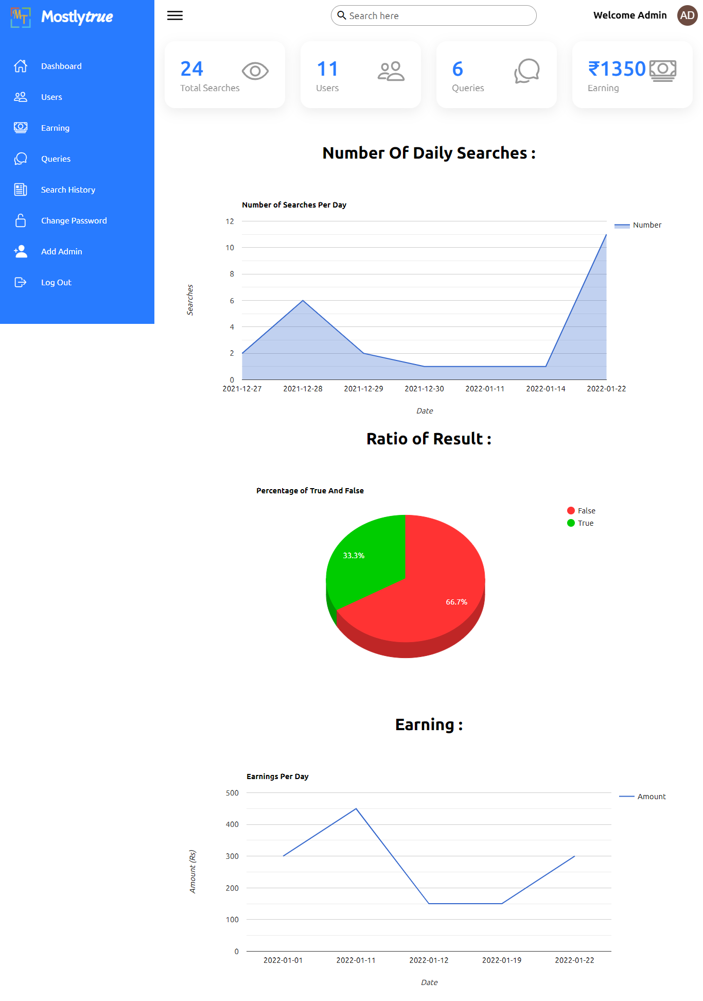

**REGISTERED USERS**

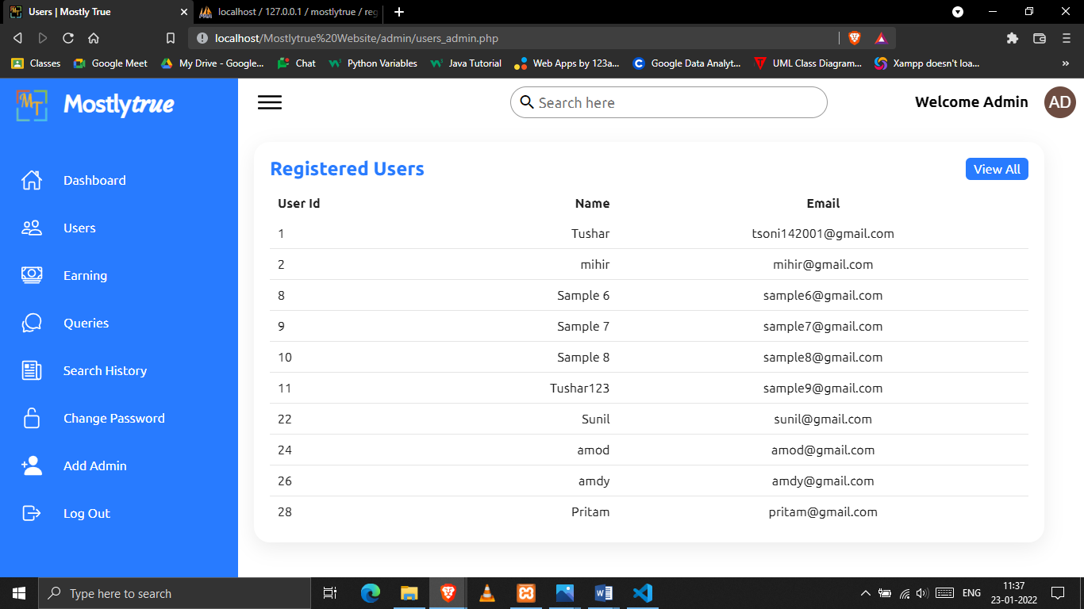

**EARNING**

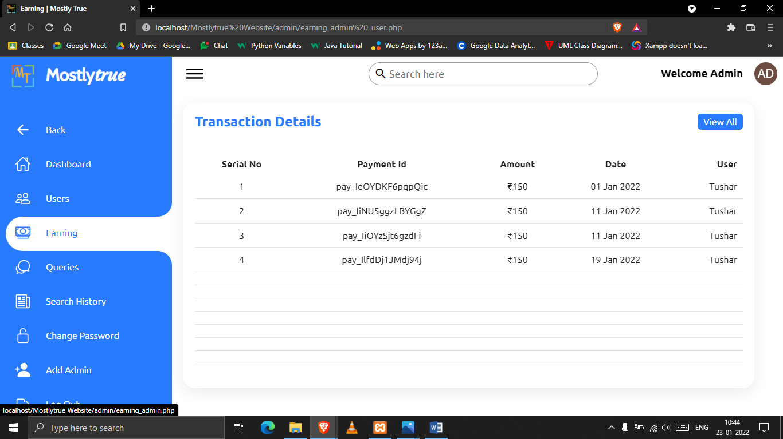

**QUERIES**

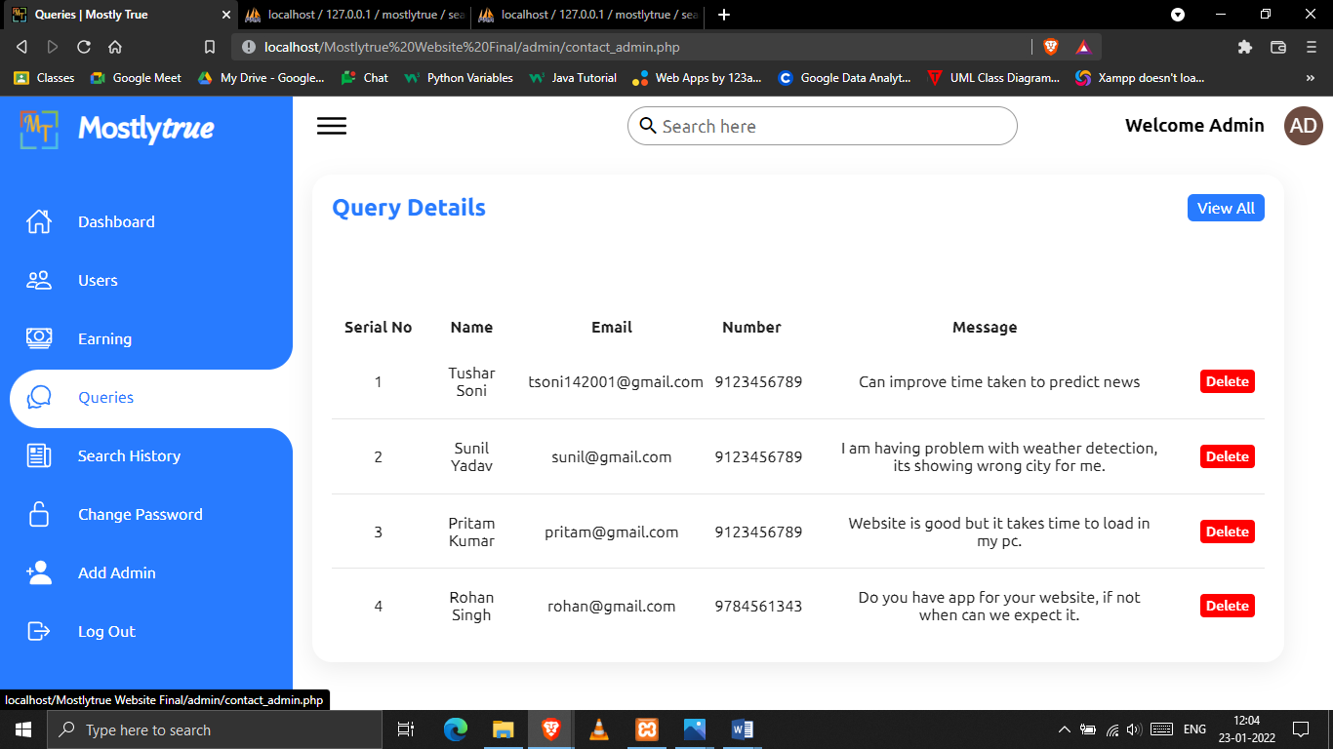

**SEARCH HISTORY**

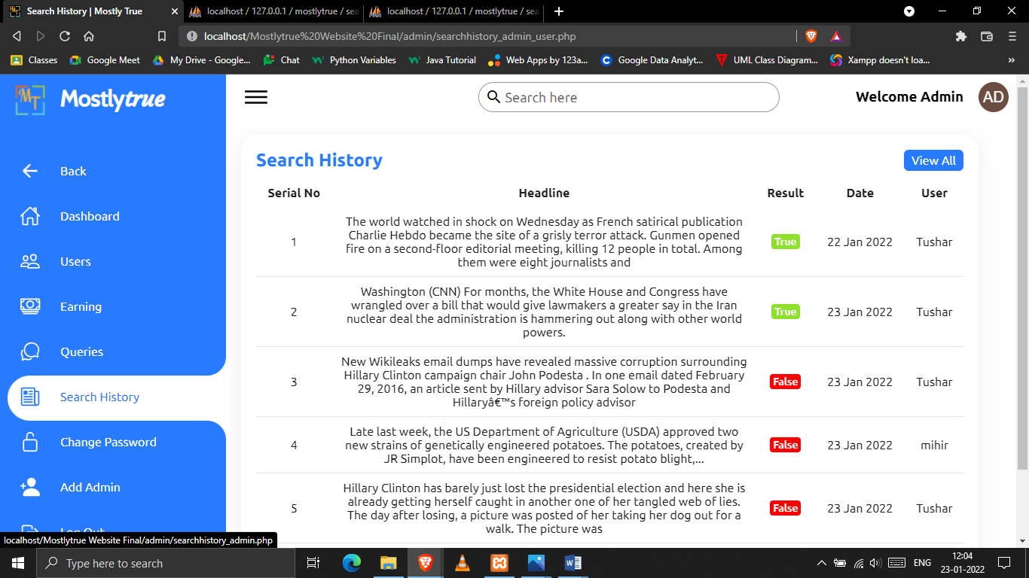

**CHANGE PASSWORD**

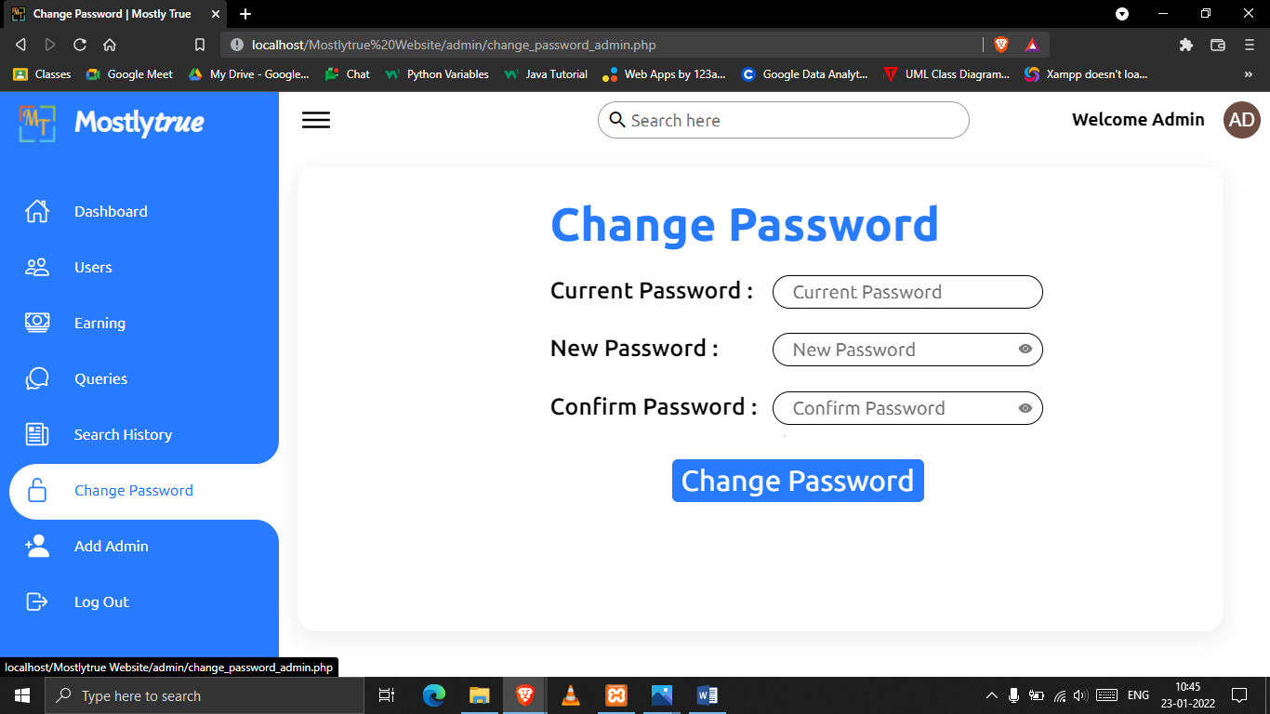

**ADD ADMIN**

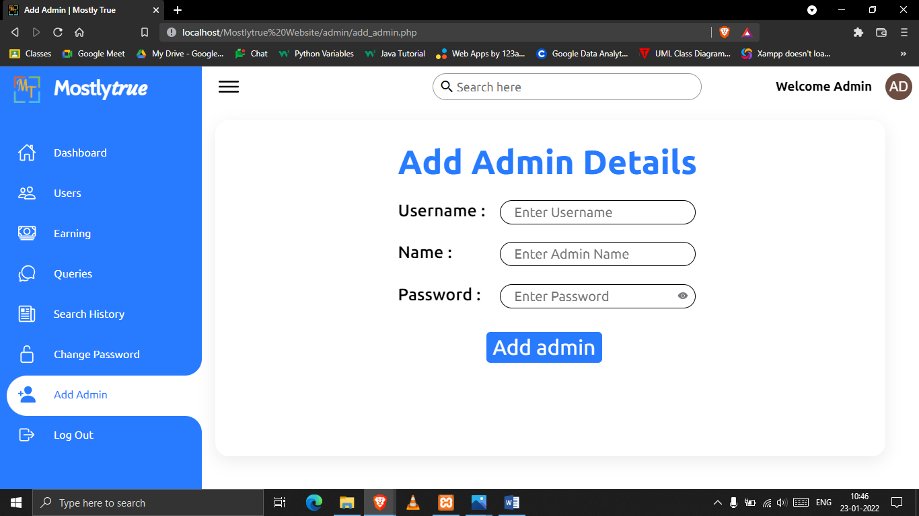

**USER DASHBOARD**

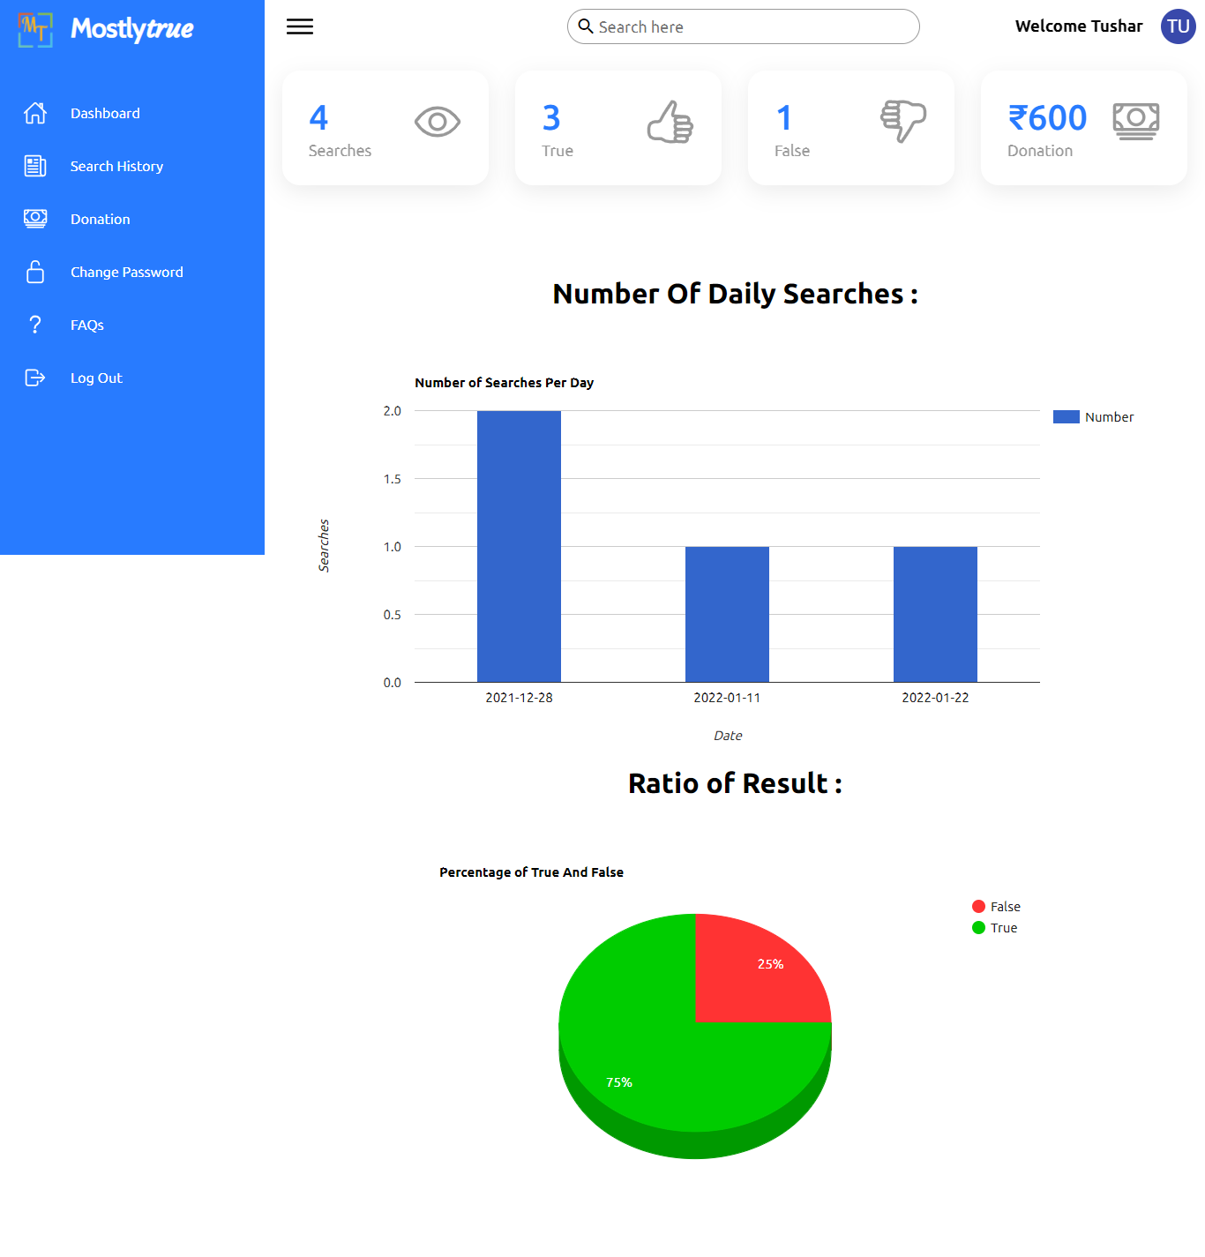

**SEARCH HISTORY**

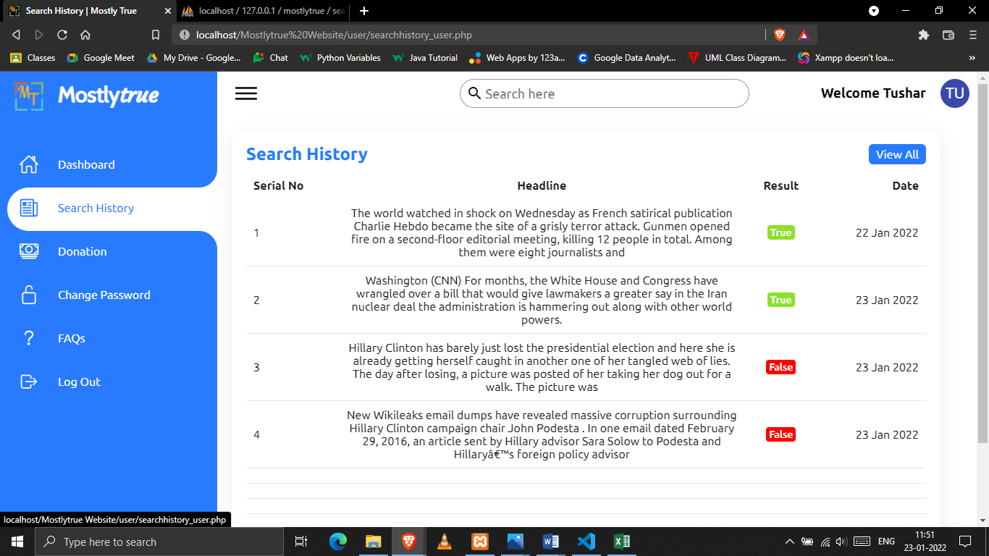

**DONATION**

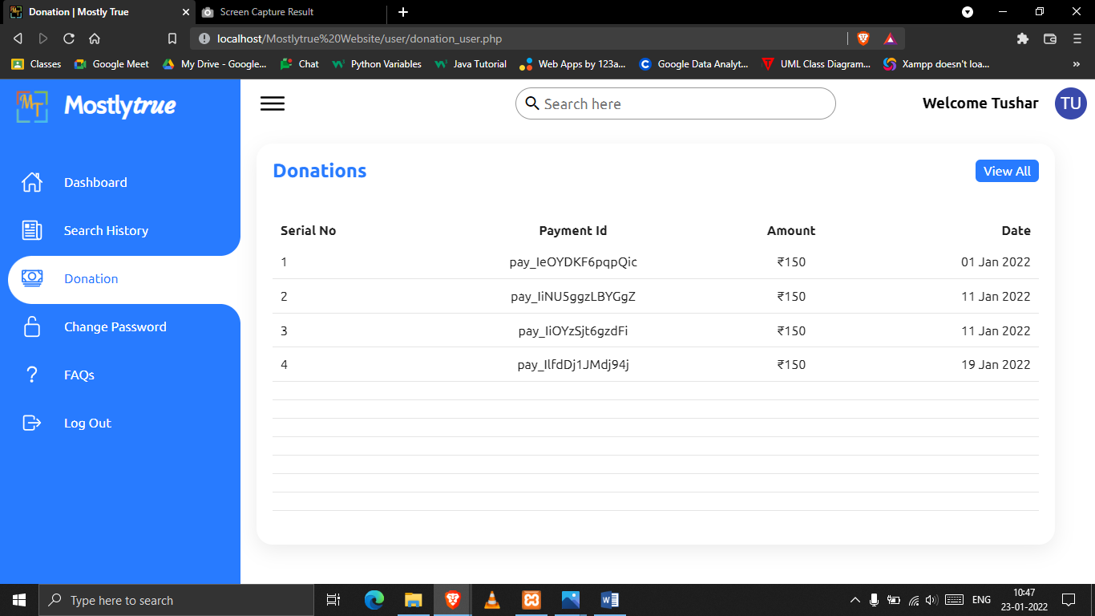

**FAQs**

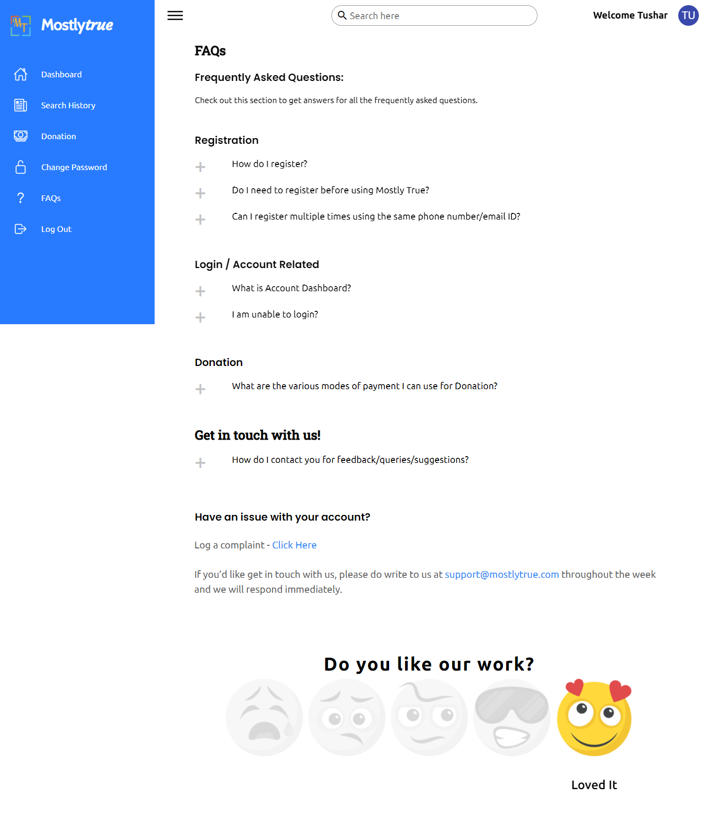

**CHANGE PASSWORD**

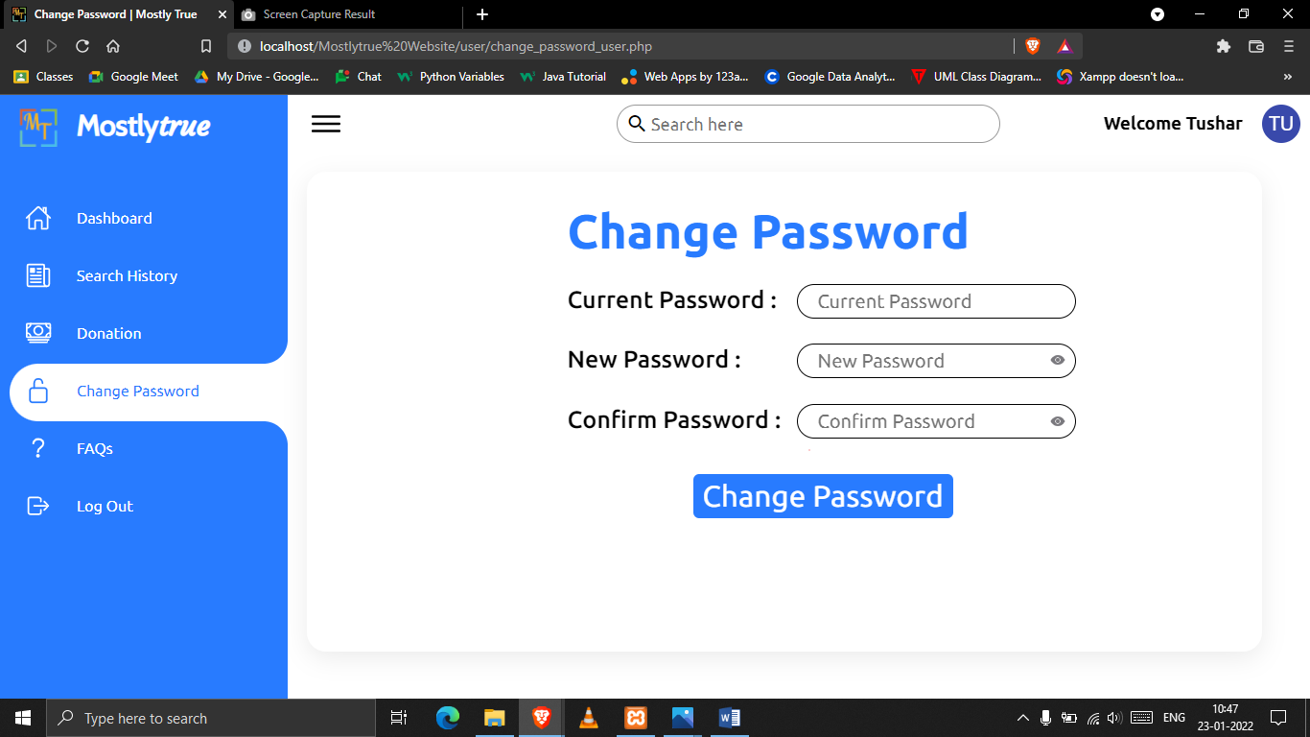

FUTURE ENHANCEMENT:

*The project has some prospects that can be considered for further improvements.*

*The possible scopes of improvements are as follows:*

* *The proposed project currently runs on a local host. By using the method of port forwarding entire internet can be accessed. This will result in enhancing the database of the project.*
* *Currently the project proposed will operate via supervised learning. This will leave a vast scope of furtherance. Unsupervised learning can be implemented in the later phase which will improve the speed and accuracy of the fake news detector.*
* *This project proposes a backend mechanism of the fake news detection and also presents an application of the same through a website. This backend algorithm can also be incorporated in the different social media platforms like WhatsApp, Facebook, Telegram, Twitter etc. This will increase the accessibility for the users by leaps and bounds.*
* *We can add search functionality in admin and user dashboard for better reach of data for admin and user.*

Limitations:

* *We can improve the machine learning algorithm to reduce the time taken for prediction.*
* *Currently, this model provides 93.69% accuracy, we can use a better machine-learning algorithm to provide better accuracy.*
* *This model requires a large amount of data to be processed at cloud storage so it requires more cloud storage than average as it is ever-expanding.*
* *We are currently using the old dataset which is not up to date and there is no updated dataset available in the market. It is very difficult to find a real-time dataset.*

BIBLIOGRAPHY:

***Reference Websites:***

*➢ W3Schools (*[*w3schools.com/python*](https://www.w3schools.com/python/)*)*

*➢ GeeksforGeeks (*[*geeksforgeeks.com*](https://www.geeksforgeeks.org/)*)*

*➢ Stack Overflow (*[*stackoverflow.com*](https://stackoverflow.com/)*)*

*➢ Online Tutorials (https://www.youtube.com/c/*[*OnlineTutorials4Designers*](https://www.youtube.com/c/OnlineTutorials4Designers)*)*

*➢ Machine Learning Hub (https://www.youtube.com/channel/*[*https://www.youtube.com/channel/UCgyQ4pSntDf9hw9Rv4hmNBA*](https://www.youtube.com/channel/UCgyQ4pSntDf9hw9Rv4hmNBA)*)*